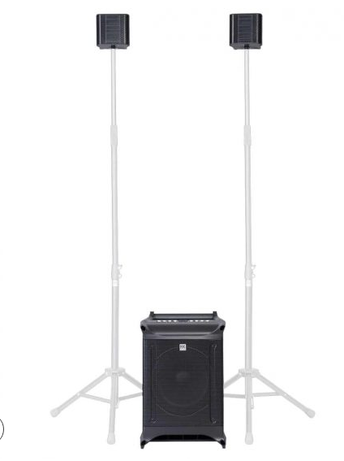

LUCAS NANO 605 FX
EVP/SRP*:
*empfohlener Verkaufspreis / Suggested Retail Price
Merkliste
E-Mail

- Description

- Techn. Data

- System Proposals

- Accessories

- LUCAS NANO Series Feature Chart

- Videos

- Downloads

Techn. Data

LUCAS NANO 605 FX system
Product Class | Portable stereo PA system
Audience | up to 120
Max SPL peak | 130 dB
Frequency response +/- 3 dB | 43 Hz - 20 kHz
Power Rating | 460 W (RMS)
Peak power (calc.) | 1500 W
Amplifier | Class D
Active protection circuits | MulitBand limiter, Subsonic filter, Thermo protection, Overload protection
Enclosure | Surface-coated Polypropylene
Optional accessories | S-CONNECT POLE LN (signal-routing speaker pole), Stereo Stand Add-on, Roller Bag (padded trolley), Desk/Wall Mount, Link Cable, Drum Rack Adapter
Weight | 16,3 kg / 36 lbs.

LUCAS NANO 600 Series Satellite

LUCAS NANO 605 FX Subwoofer

